Objective writing 101
Psychomotor Domain | PE.5.M.S.1.1 /1 | 1. By the end of task 1, students will be able to perform the bump by having position, platform, and push without errors in their form.
Step one- determine the domain of learning
Psychomotor- physical skill (manipulative, locomotor, non-locomotor)
Cognitive- addresses the development of content knowledge and intellectual skills
Affective- thoughts, feelings, and/or attitudes
Fitness-technically not a domain but a main item when considering PE. Typically we try to base these on the five components of fitness:
muscular strength, muscular endurance, flexibility, cardiovascular endurance, and body composition.
Step two- determine the state objective. This will be based on your topic. You may also save this step to the end.
Step three- state the situation; it can be: by the end of the instant activity/task 1/ task 2/task 3 or by the end of the lesson. This is generally when the assessment will happen.
Example: By the end of task 1,
Step four- write students will be able to
Example: By the end of task 1, students will be able to
Step five- Write the verb and skill. For a list of verbs see the tables below
Example: By the end of task 1, students will be able to perform the bump
Step six- state the criteria. This must be measurable formally or informally. Typically, we start with the word by, via or through. The criteria will depend on the domain of learning. Generally, with the psychomotor domain the objective will have the qualitative part of the skill. You may in addition do skill attempts, but that is almost unrealistic to measure. Imagine having 25 kids and watching the bump 5 times each….That is why I say its generally better to stick with the qualitative components. With the cognitive domain it can be but not limited to worksheets, exit slips, teacher observation of criteria, CFUs, rubrics, checklists, implementation of strategy ect. The aforementioned also be extrapolated to the affective domain.
Example: By the end of task 1, students will be able to perform the bump by having a position platform and push without errors in their form.

***Note this is a general list from all subjects.
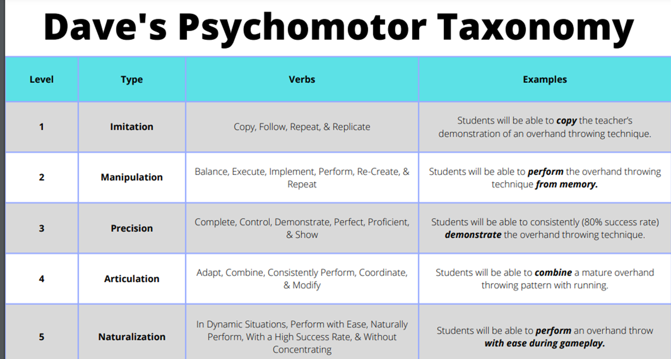

Cognitive Domain
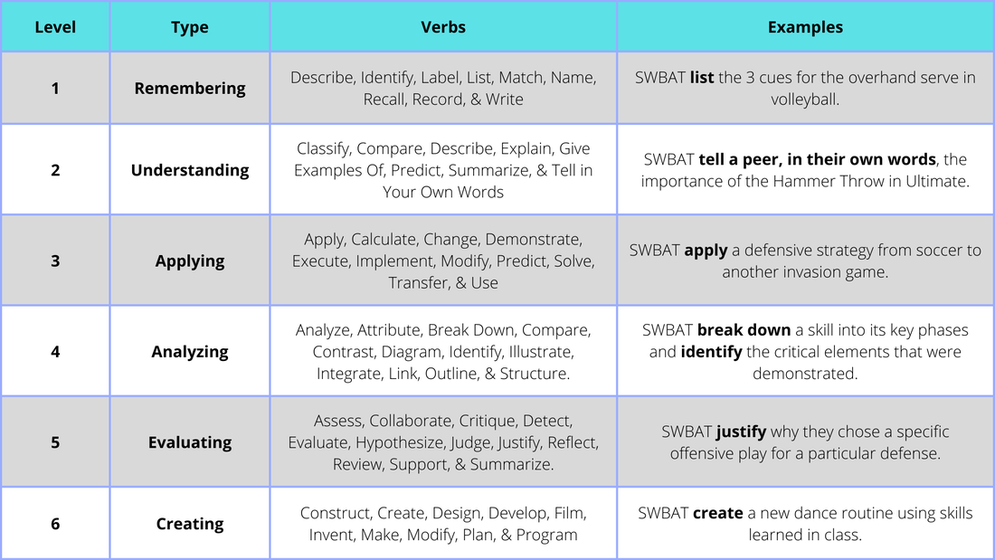

Affective Domain
